Programming Assignment 1:

Google Search Engine Simulation

Yuxiao (Tom) Zheng

CS146-Section7

1. Unzip and Installation

2. Programming Design(Object-Oriented)

3. Implementation

4. classes/subroutines/function class:

5. Self-testing

6. Problems encountered during implementation

7. Leasson Learned

8. Updating (Debugging Report)

1. unzip and install

* Clicking the GoogleSearch.zip and unzip PA-1.zip into an empty folder, all .java files will be on the src folder. Note: the all .png imags must be outside of src folders, then the Intellij or Eclipse can find the .png file.

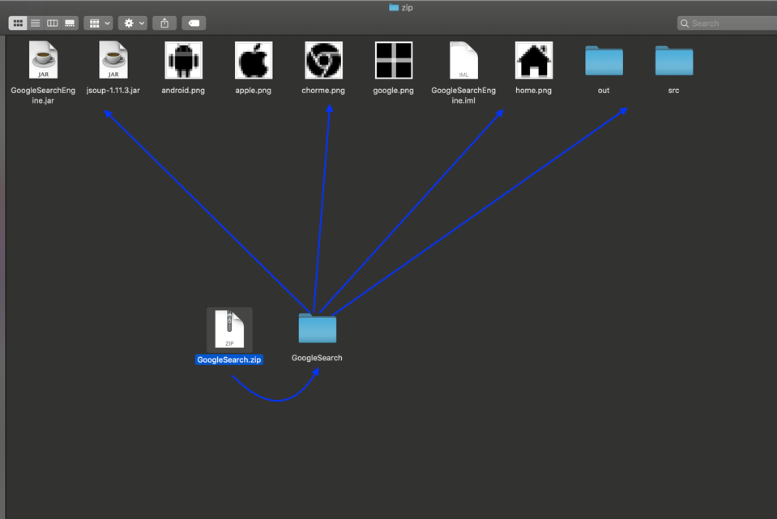

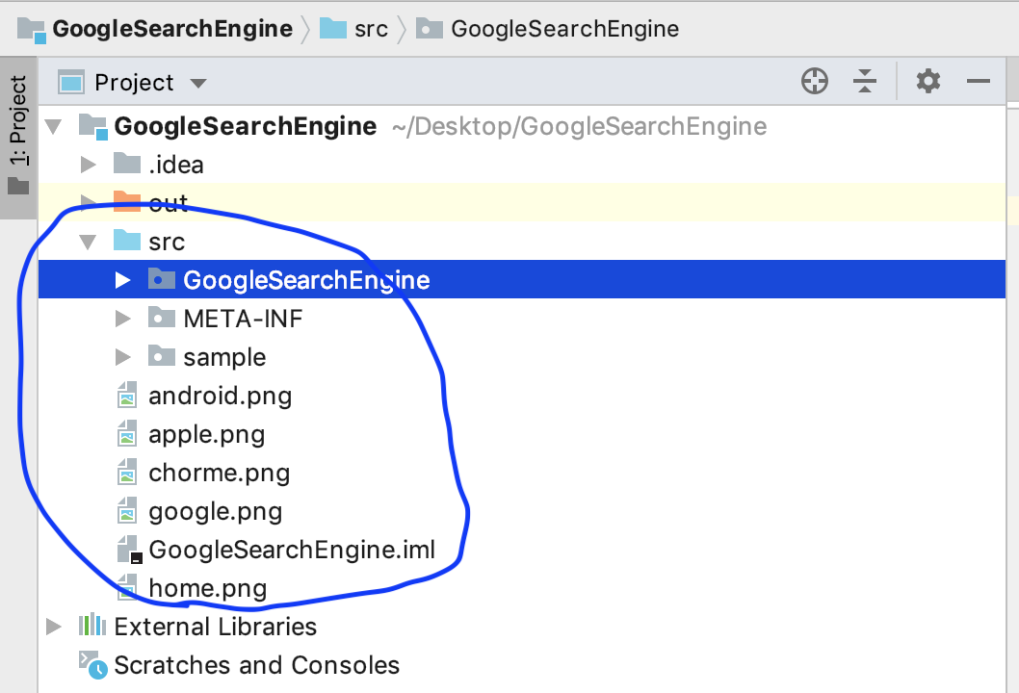

* Click the SRC folder,

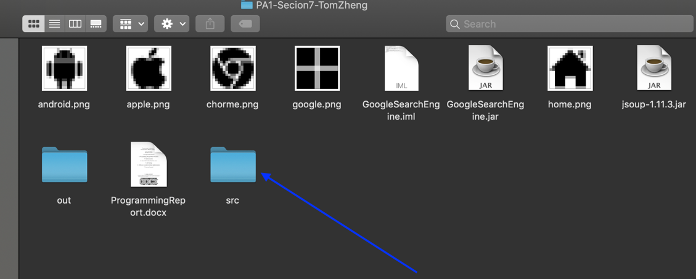

* Click the GoogleSearchEngine

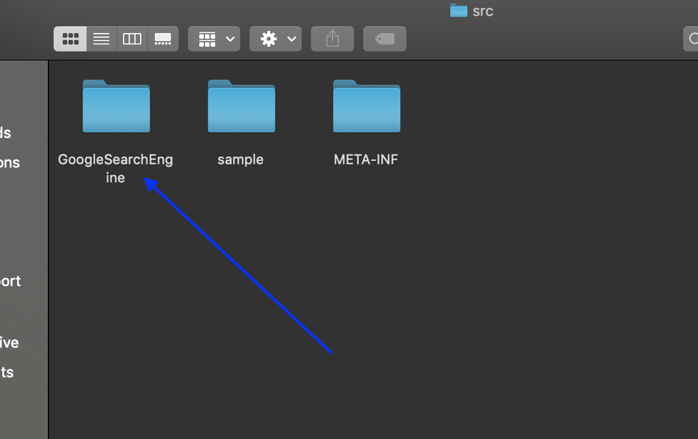

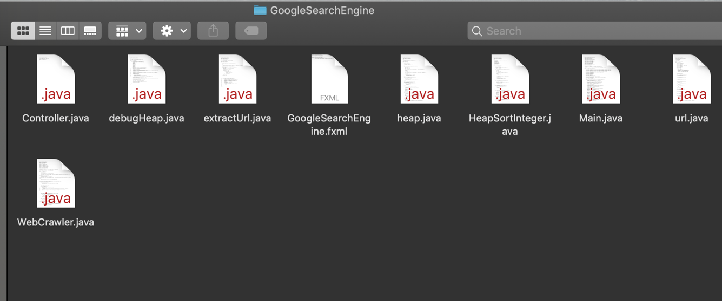

* Clicking the File $→$ click Project Structure. First creating a Package GoogleSearchEngine put all source files including .java files into the Package, this Package must be into SRC folder.

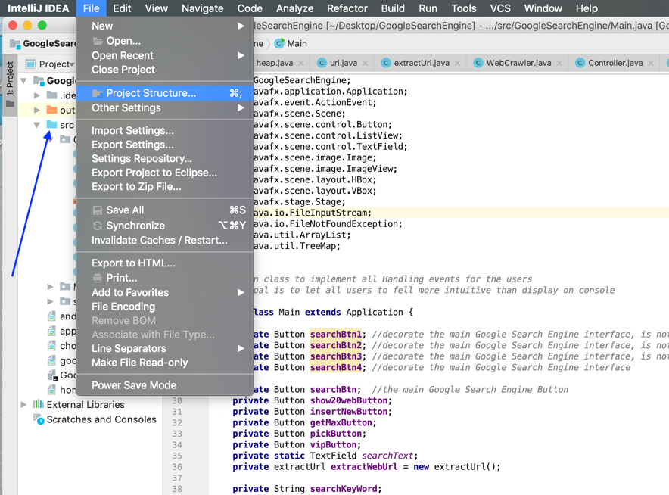

* After clicking Project Structure, click “+” it will import jsoup-1.11.3.jar. You will be using the all methods for extracting the web url by WebCrawler class.

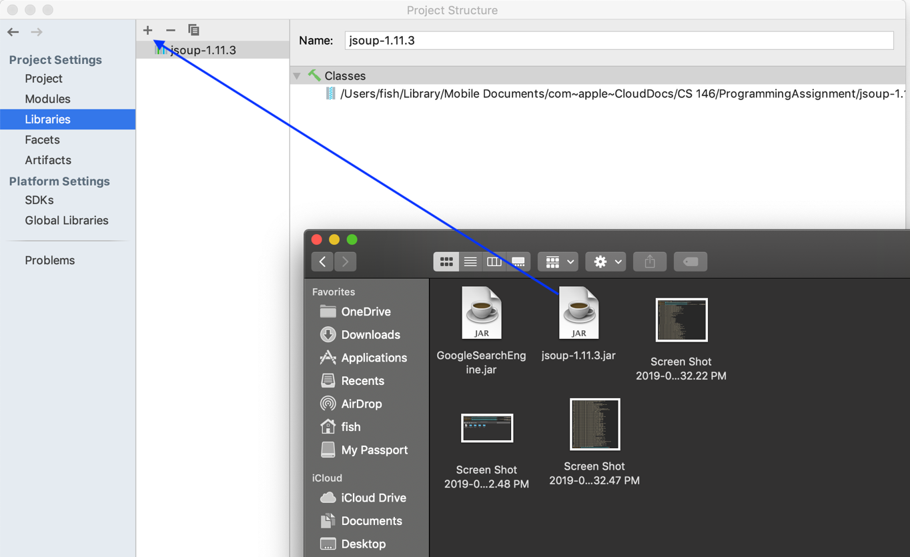

* Note: Eclipse with JDK 8 under can export project into Runnable Jar, but not JDK 9. Therefore, I import JDK 8 for Intellij or Eclipse.

Firstly, click the “SDKs” button, and click “+” button. $→$ importing JDK 8.

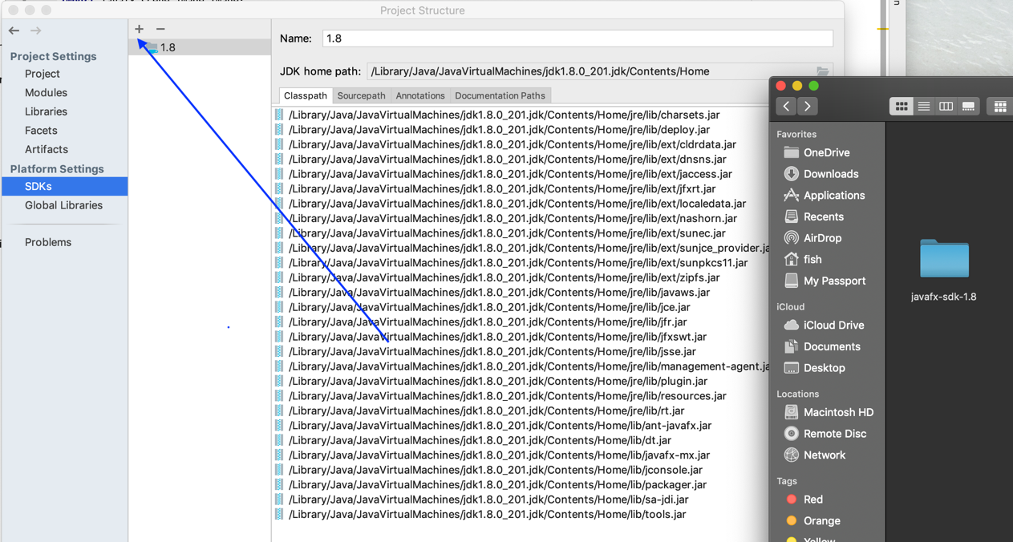

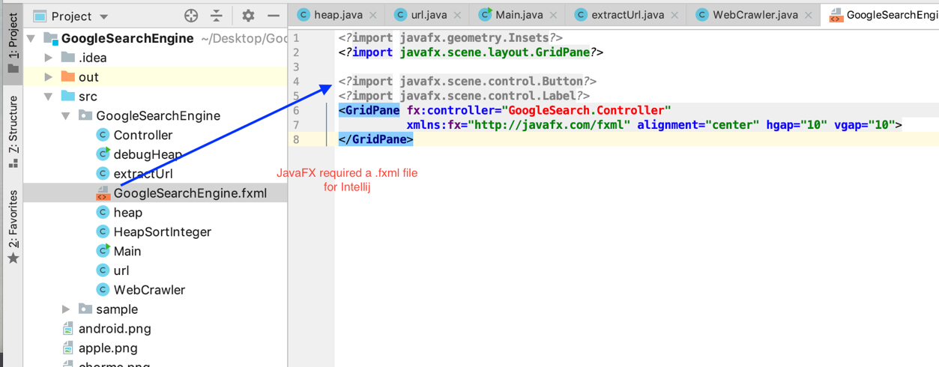

* To summary, all .java files $→$ GoogleSearchEngine Package; all .png files is out of SRC folder; You must import JDK 8.

2. Programming Design

* Importing JavaFX lirbary, it will make the USER INTERFACE more percetual intuition, beautiful, and clean.
* Adding some .png icon images into this project, they will make the buttons more active and detailed.
* Importing the Jsoup lirbary into this project in order to use the WebCrawler class; we need WebCrawler to implement the extractUrl class.
* My extractUrl calss must aggreate the URL class, because all web urls that WebCrawler will capture, which will add into the ArrayList<url> for the Main class implementing different functioning for the users.
* The Main class depends on heap class and extractUrl, it was also aggreating with url class. The extractUrl class depends on WebCrawler class; it was also aggreating with url class.
* The different button-event method will using lambda expression to implement functioning.

There is a UML diagram below:

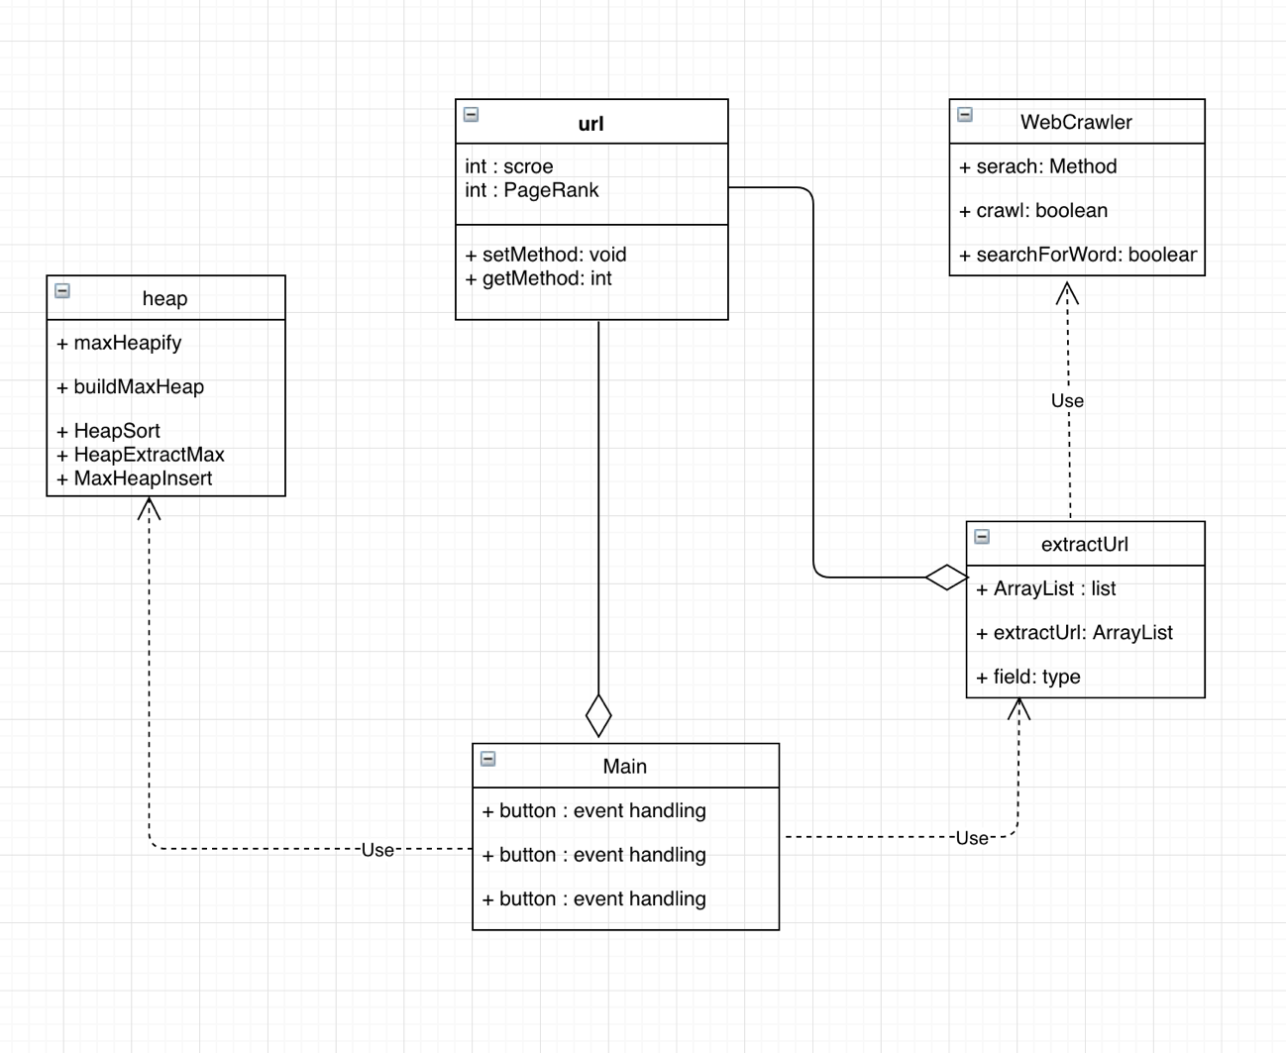

* The Main class will register any required event listeners on all the Buttons componets.

The bellow is the Main-class Sequence Diagram:

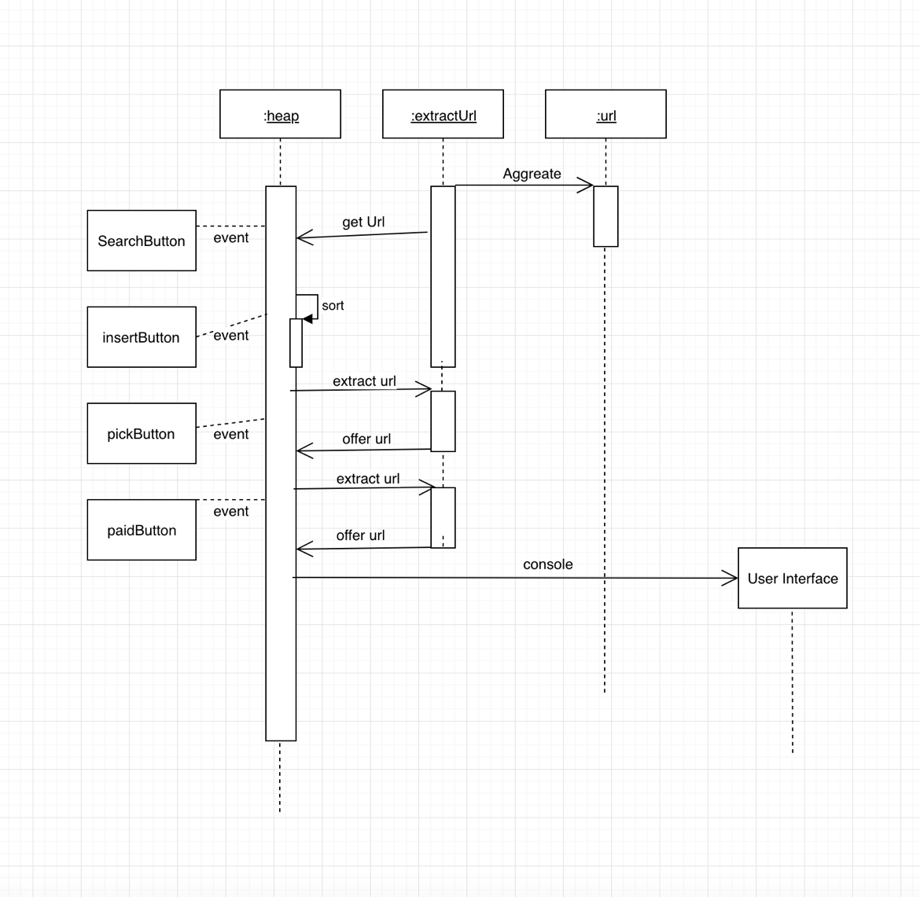

* All buttons will each fufill their purpose to finish different functioning excepct the SearchButton execute the primary task.
* The heap class will call iteself by invoking the method HeapSort in ascending order when the user hope to resort the ArrayList<url> to execute their appeals.
* In the lifetime, the extractUrl always play a large role to provide the web url that the users hope to get.

3. Implementing functioning

* The user UI Interface will hold the primary buttons: Google Search, Show20topLink, insertNewUrl, extract max PageRank, Pick a webUrl, and VIP Pay$ AD.
* Note: the Google scholar, Find a Job, Google Chorme, iMac is only to decorate the user interface. They aren’t meaningful.

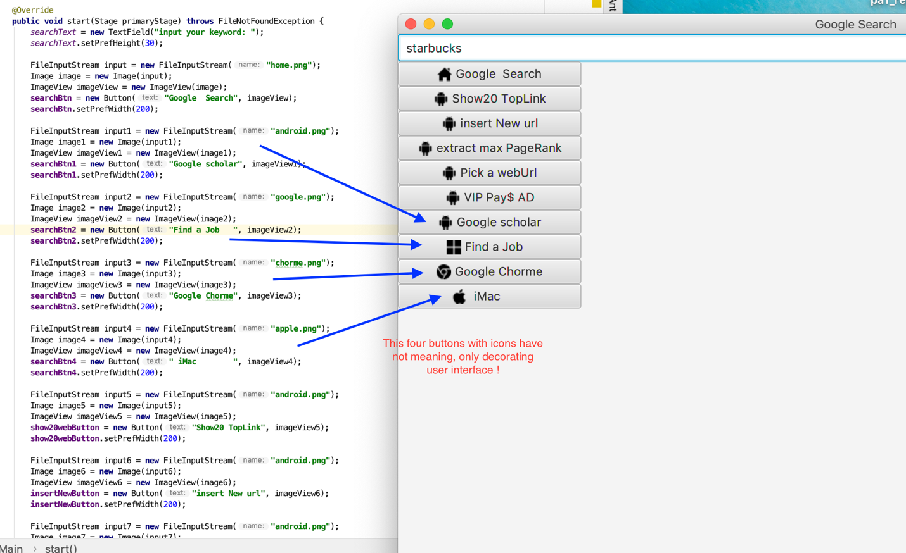

* When clicking the SearchButton, it will fire an event to all of the registered listeners with the object being updated, the cation of the update, the value before, and the value now.
* $→$ calling the extractWebUrl(KeyWord) to get the web url into the ArrayList.
* $→$ Printing out the first 30 elements.

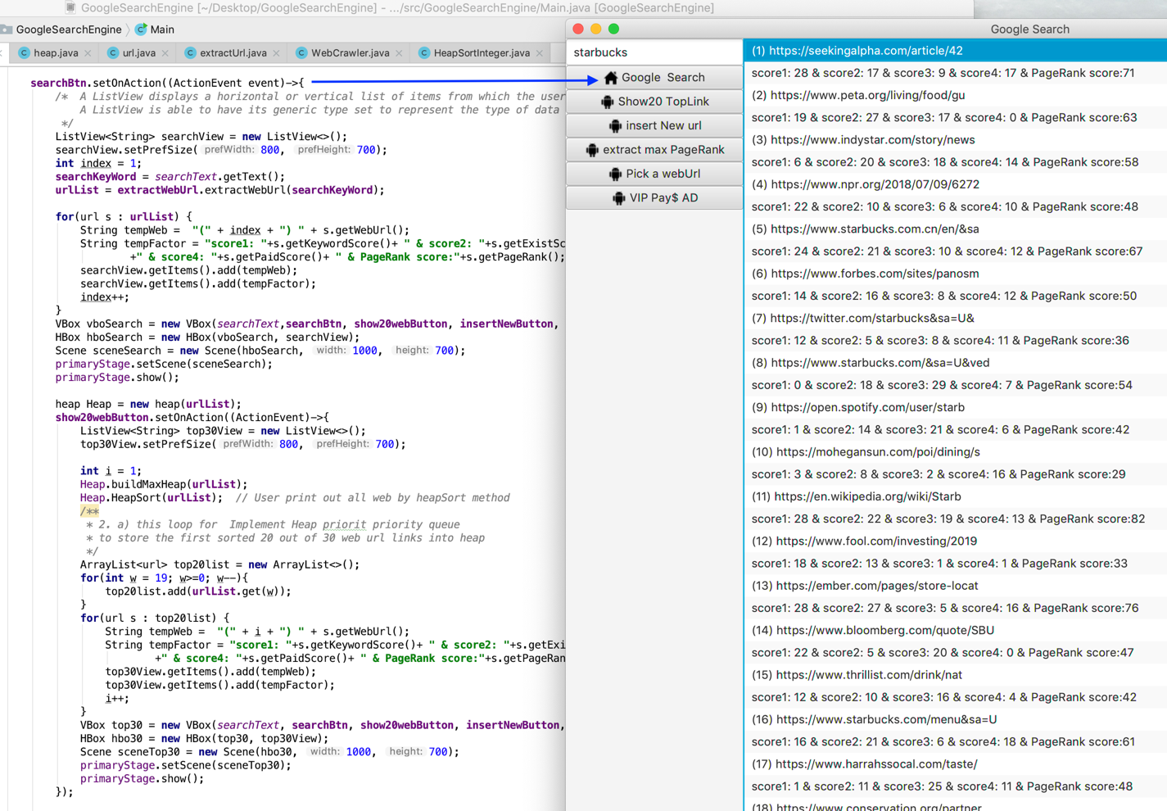

* Implementing ‘Show20 TopLink’ button $→$ calling Heap.buildMaxHeap(A) and Heap.HeapSort(A). Displaying the 20 out of 30 web url by descending order since the HeapSort method sorting the ArrayList in desceding order.
* The web url elments sorting like this: PageRank 61 $→$ PageRank 58 $→$ PageRank 54 $→$ PageRank 52 $→$ PageRank 51 $→$ PageRank 50 … …

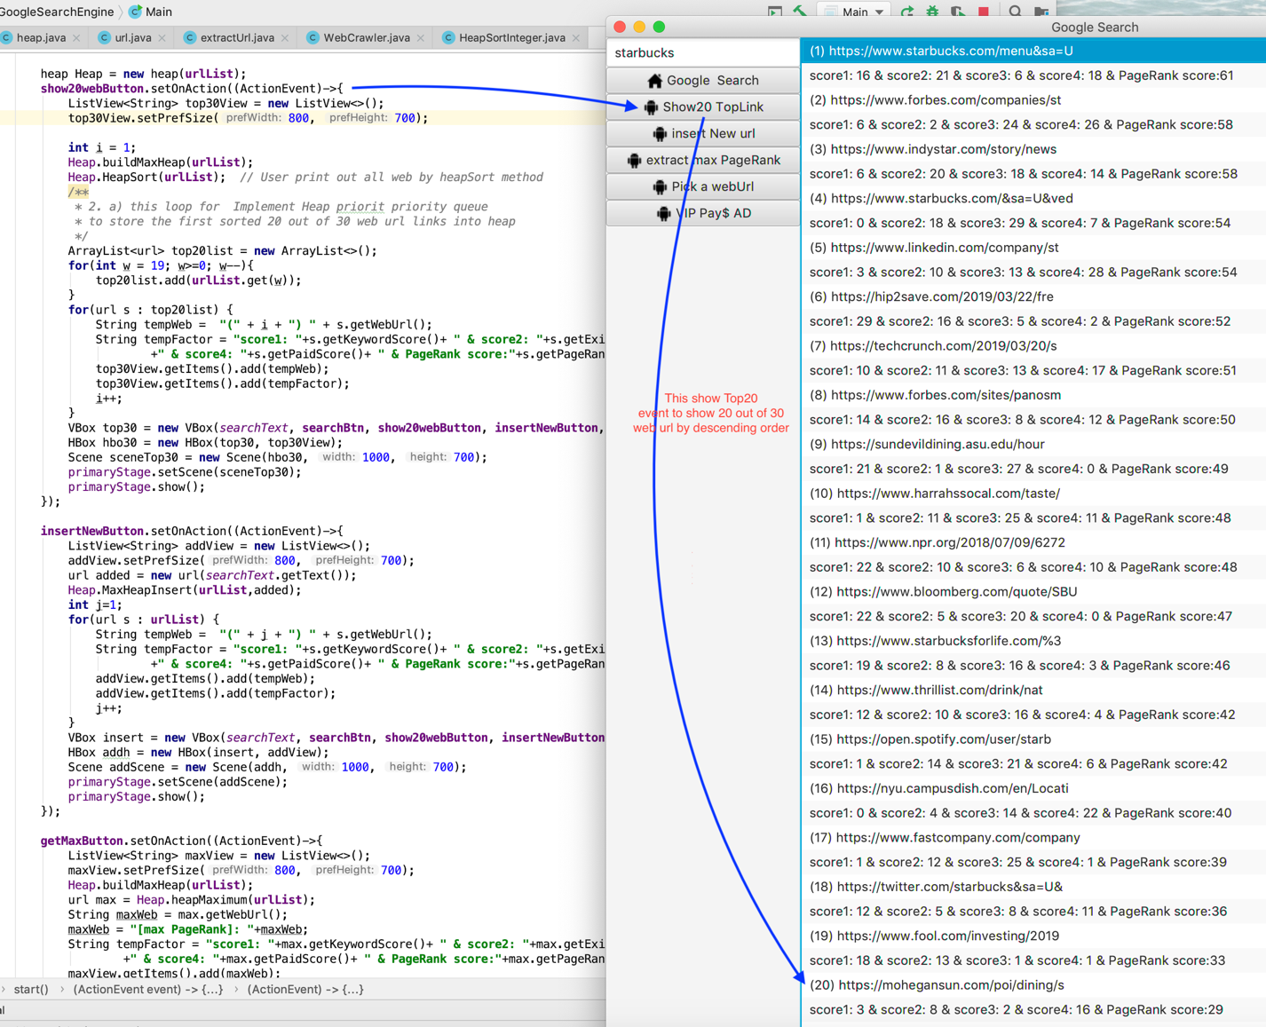

* Implementing “insert New url” button, insert Event $→$ input <https://www.apple.com>

click insert New url Button $→$ added a new web url into the heap By call MaxHeapInsert(A, key) mehod to implement the (31) element into the heap Tree !

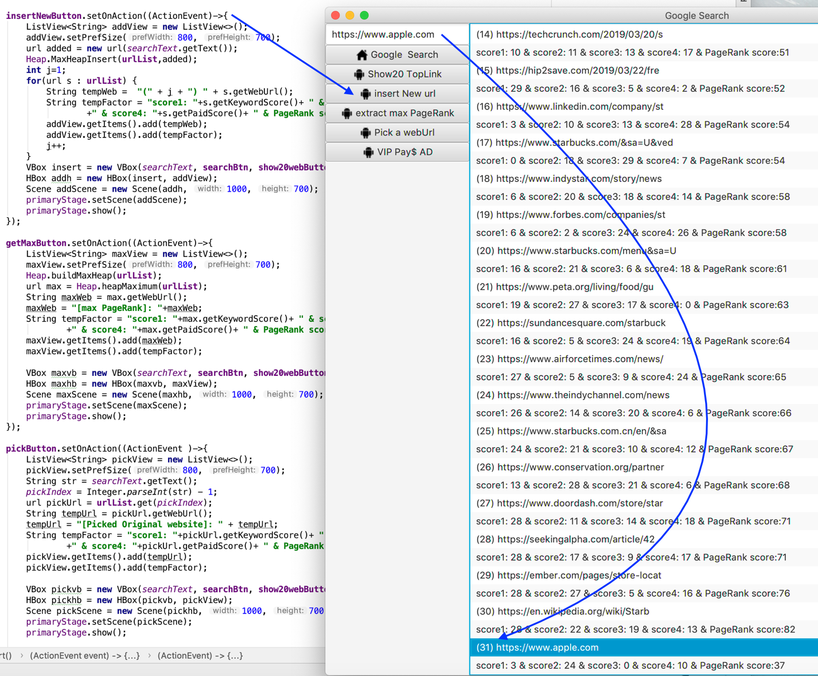

* Implementing “getMaxButton” $→$ click button $→$ calling Heap.buildMaxHeap(A)

$→$ calling Heap.heapMaximum(A) mehtod to get the max elment

$→$ displaying the result on the UI interface.

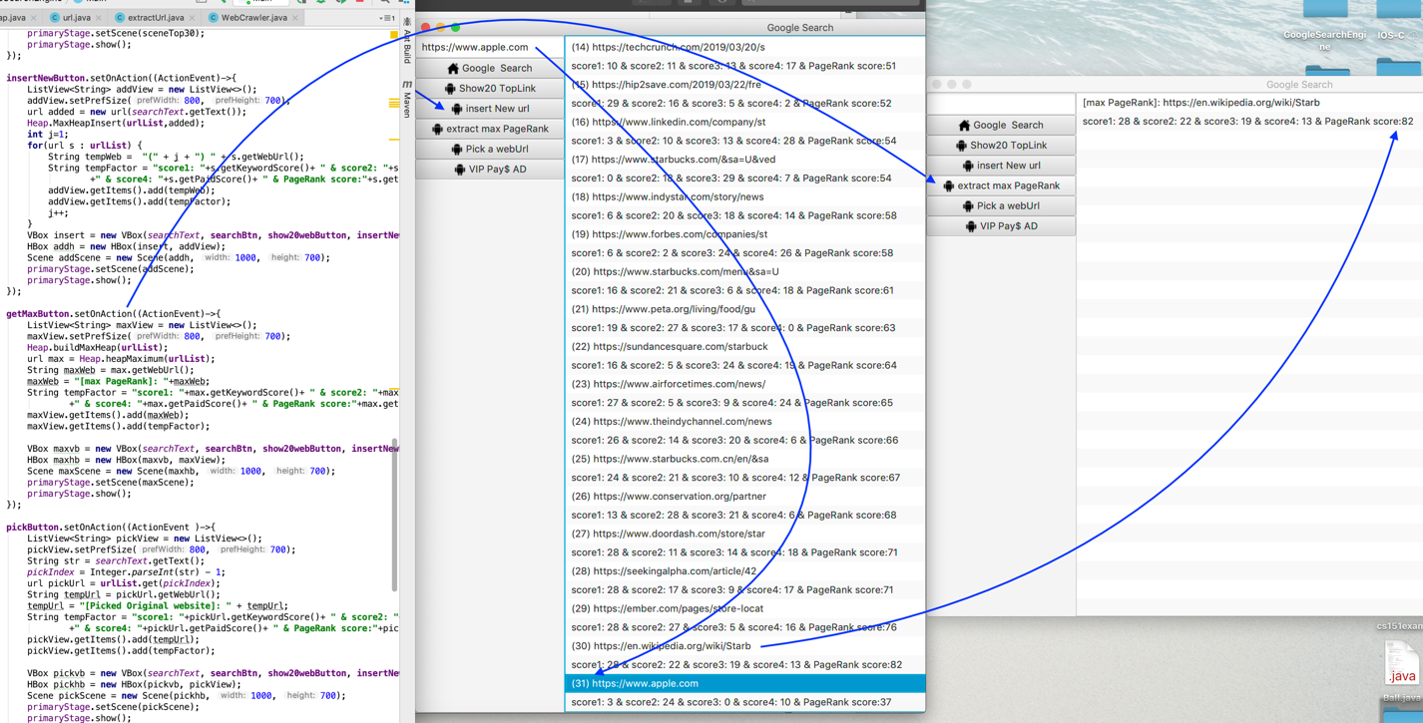

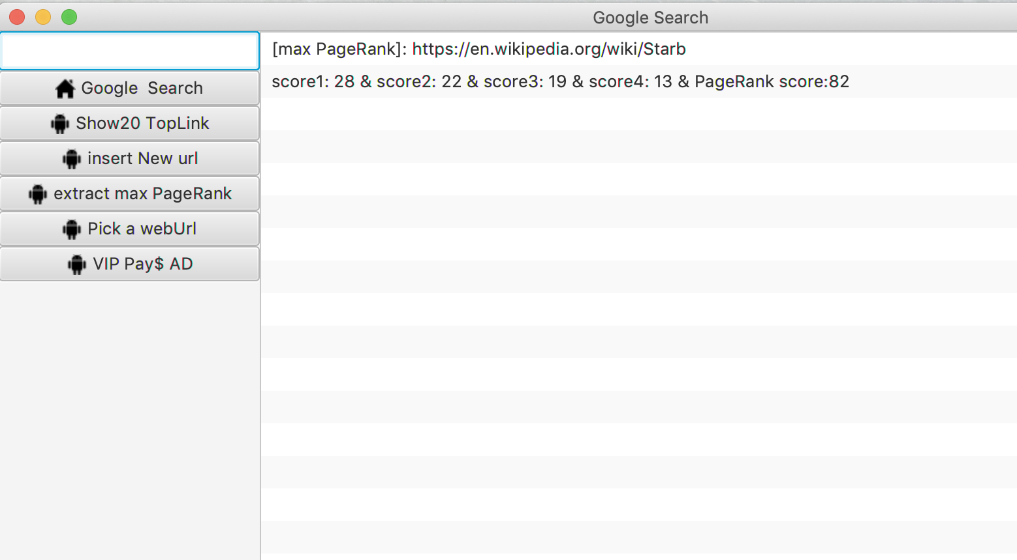

* Implementing pickButton and vipButton, $→$ clicking “Pick a webUrl” $→$ pick [[www.sfgate.com](http://www.sfgate.com)] $→$ clicking “VIP Pay$ AD” $→$ add 33 rank score into original 27 rank $→$ 33 + 27 = 60
* Including two steps: (1) $→$ pick; (2) $→$ pay $; (3) calculate total PageRank
* Create a new TreeMap $→$ call method TreeMap.put(key: Integer, Value: Integer);

key using the index , value using the getPageRank()

Finding the key $→$ then finding the value $→$ increasing the PageRank

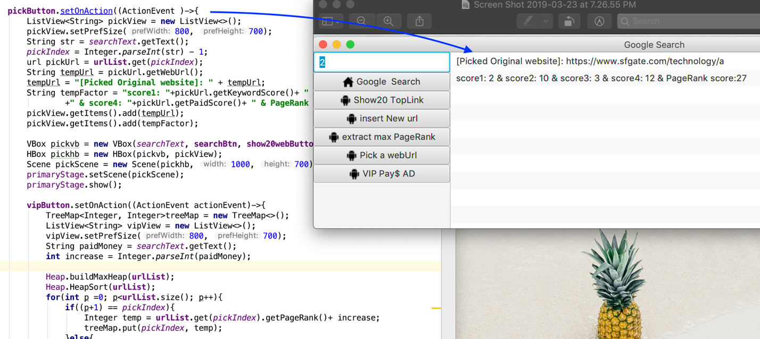

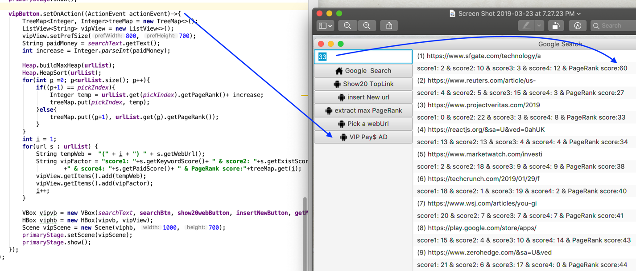

* To summary, so far so good! All functioning testing sucessfully. I have spent more than 120 hours!

4. classes/subroutines/function class:

* Class extractUrl $→$ depending on Class WebCrawler :

extractUrl’s function extractWebUrl(String keyword) will help me get the website’s address .

constructor a new WebCrawler $→$ calling wc.search() $→$ finding the required url elements $→$ creating a new ArrayList<>() $→$ A.dd(All weburls).

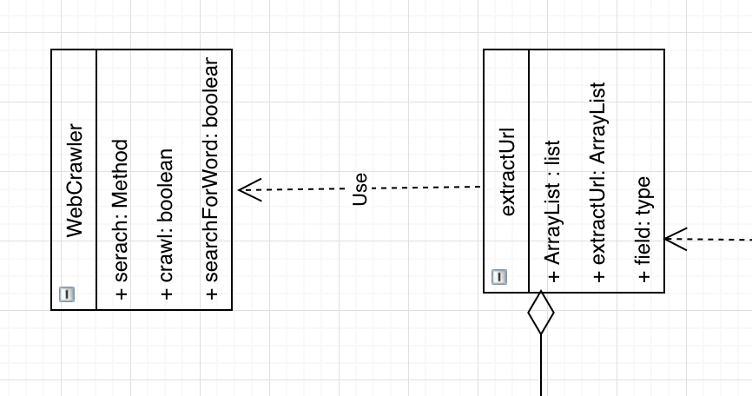

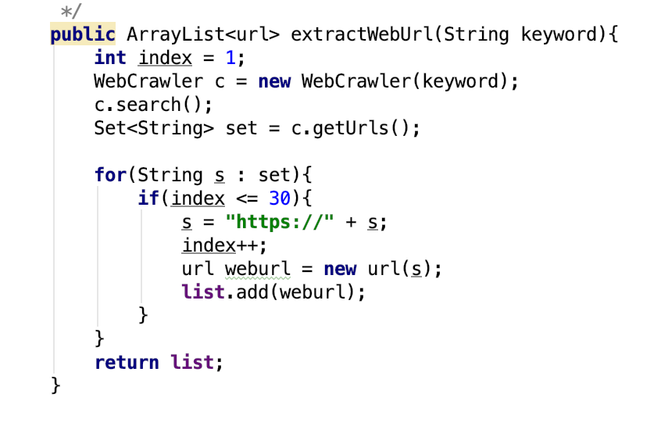

* Class WebCrawler has a constructor WebCrawler(keyword) to hold the keyword that the user inputed through Main class calling the Handing Events.
* It have imported the Jsoup lirbary, Jsoup lirbary is to help Crawler to get the url.

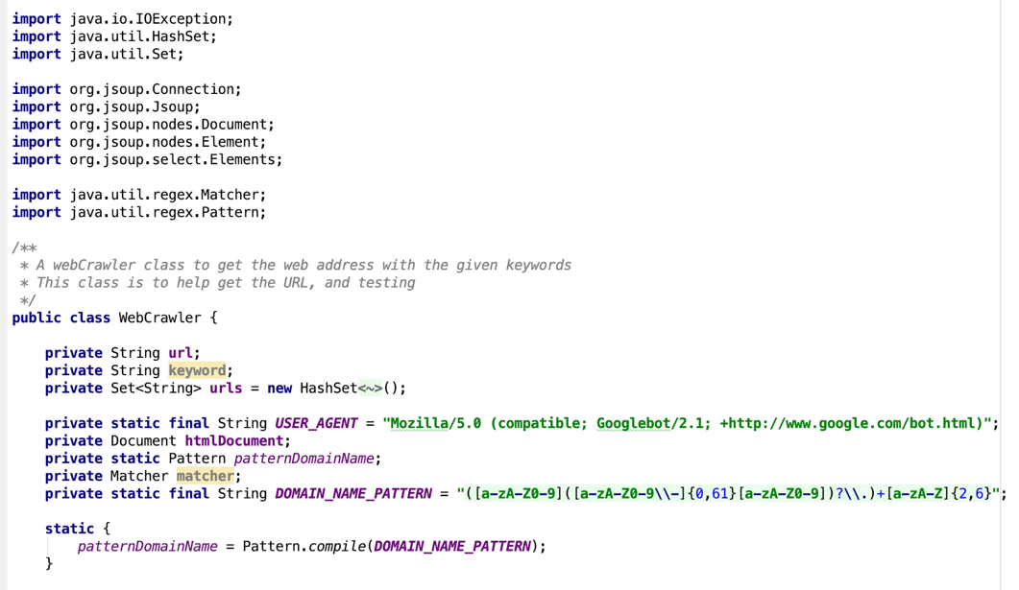

* The crawl(String url) method will crawl the links and put them in to a set to keep;

Give it a URL and it makes an HTTP request for a web page.

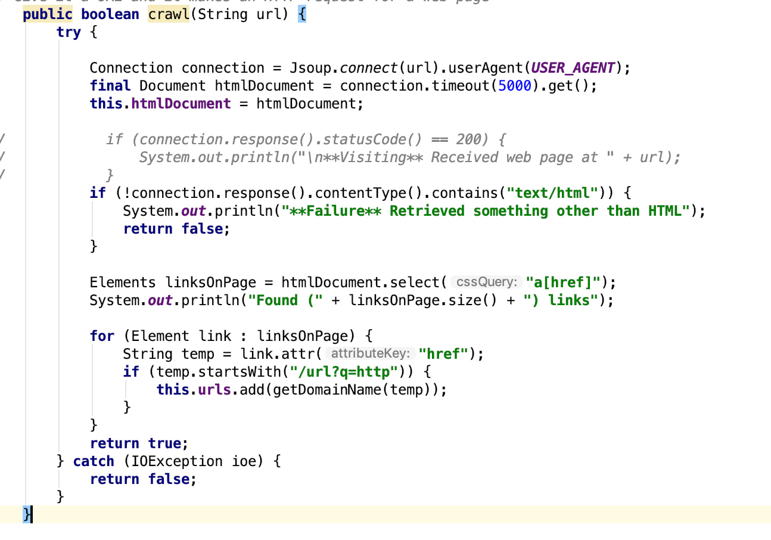

* Heap class including seven method:

1. maxHeapify $→$ is a helper function to help buildMaxHeap to create a Heap Tree.

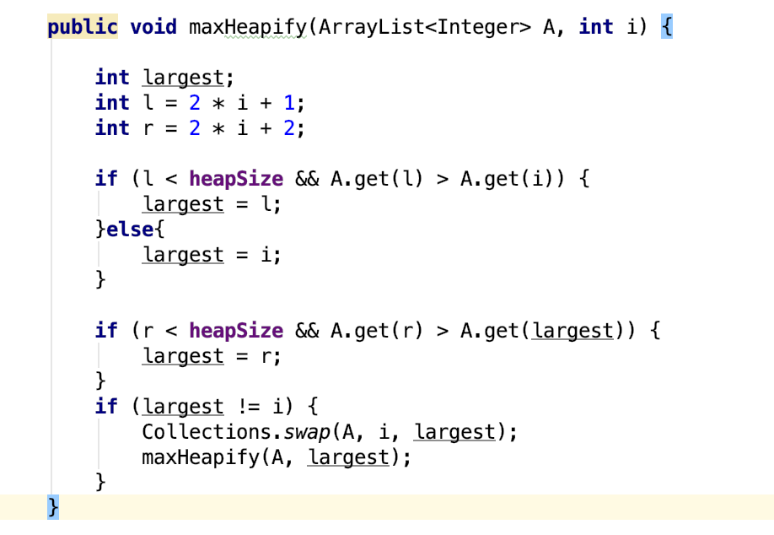

2. buildMaxHeap $→$ we can build a max-heap from an unordered array in linear time.

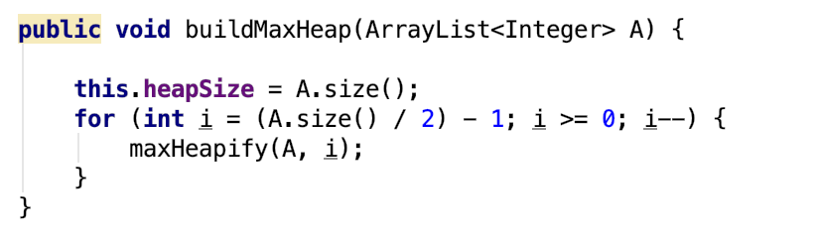

3. HeapSort $→$ After calling buildMaxHeap $→$ sort an array in ascending order.

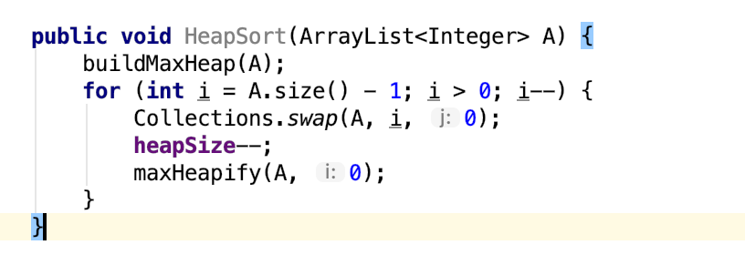

4. HeapExtractMax $→$ if heap.size < -1 throw new RuntimeExcption(“heap underflow”) $→$ calling heapMaximum(A) $→$ put the last element on the first position to replace the maximum $→$ calling maxHeapify(A, 0) $→$ return maximum

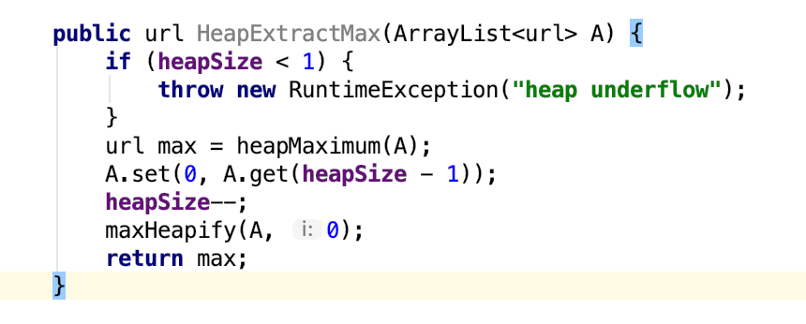

5. heapIncreaseKey $→$ Increass the value of the element I’s key to the new value k, where

k>= I’s current key value

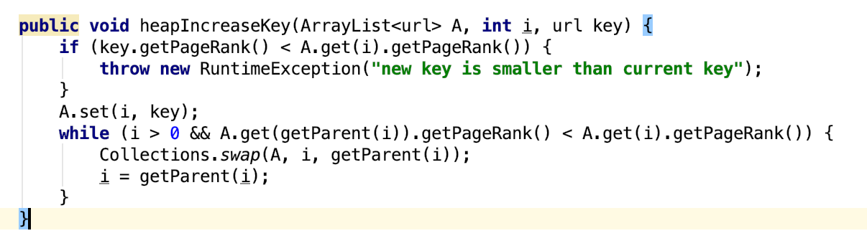

6. MaxHeapInsert $→$ insert the key into the arraylist

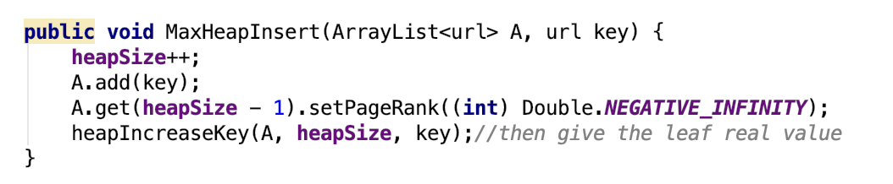

7. heapMaximum $→$ return the element of arraylist with the largest key

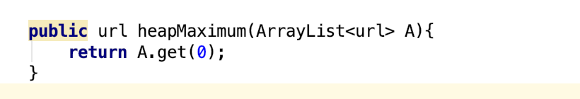

* The Main class need Heap to implement different functioning : get Maxmimu, sort an array, in brief, Main depents on Heap.

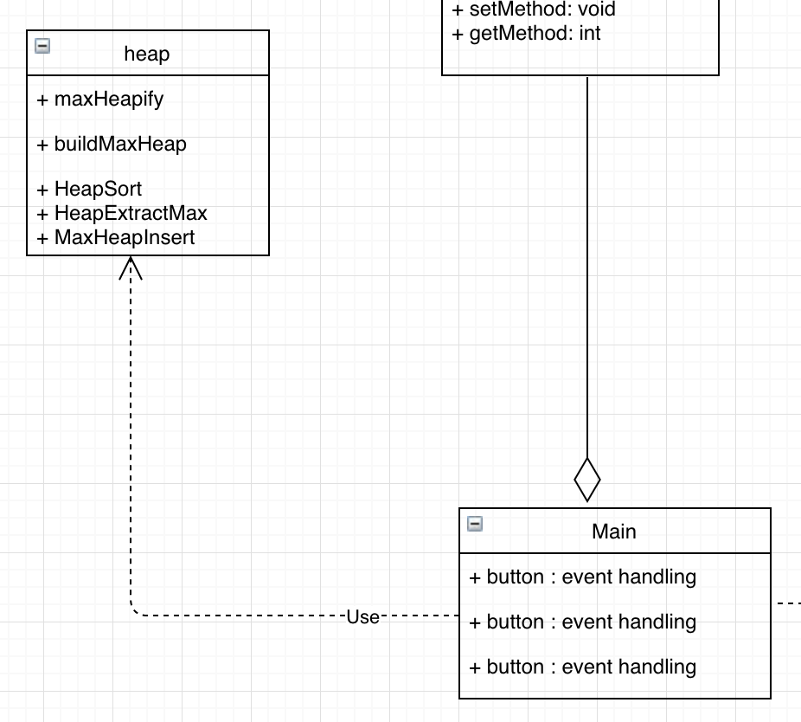

Main class method: start(Stage primaryStage)

* ListView $→$ adding datas into the UI interface
* searchText.getText() $→$ save the data that the user input
* Vbox $→$ vertical layout all buttons; the bottons will be vertical; contain the searchText
* Hbox making vertical button on the left, the console of the UI interface will on the right
* Scene $→$ contains the Vbox, Hbox, ListView
* primaryStage $→$ holds all above components.

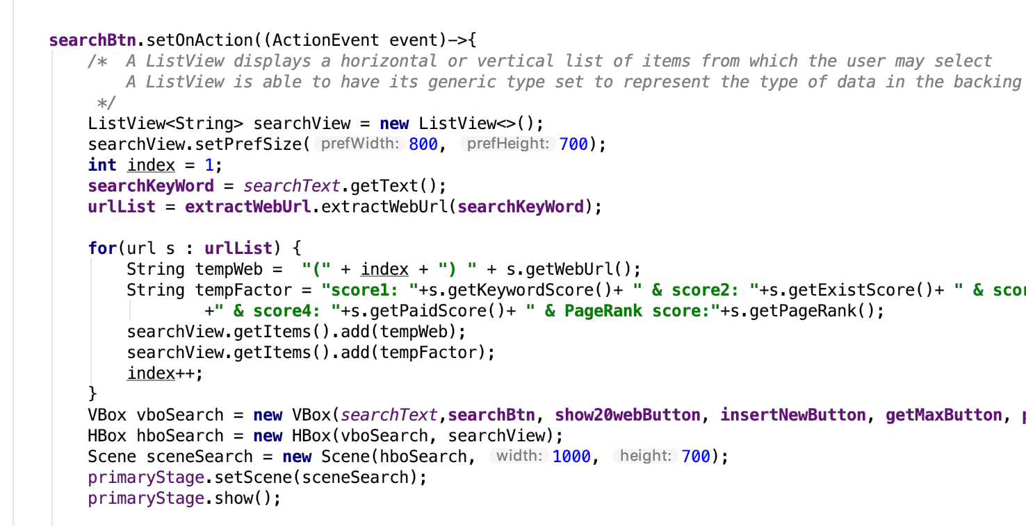

* All buttons:

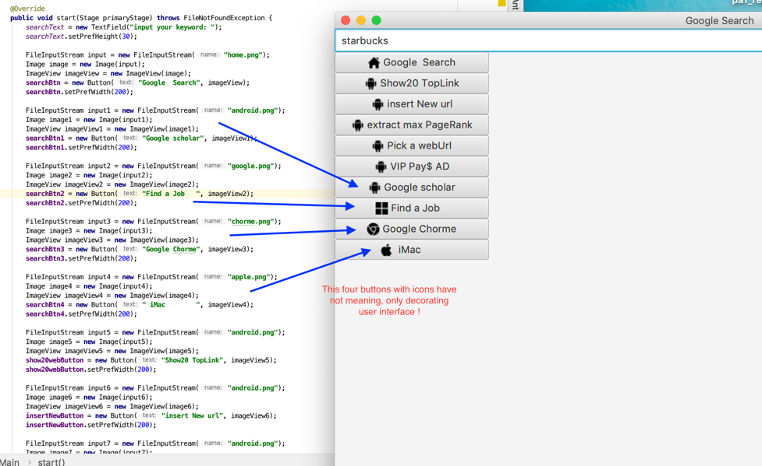

* Show20webButton : displays the top 20 web url in descending order

$→$ call HeapSort $→$ arrayList adds all elments in descending order $→$ print data

* ListView $→$ adding datas into the UI interface
* searchText.getText() $→$ save the data that the user input
* Vbox $→$ vertical layout all buttons; the bottons will be vertical; contain the searchText
* Hbox making vertical button on the left, the console of the UI interface will on the right
* Scene $→$ contains the Vbox, Hbox, ListView
* primaryStage $→$ holds all above components.
* insertNewButton $→$ add a new url elment
* getMaxButton $→$ get the maximum url elent
* ListView $→$ adding datas into the UI interface
* searchText.getText() $→$ save the data that the user input
* Vbox $→$ vertical layout all buttons; the bottons will be vertical; contain the searchText
* Hbox making vertical button on the left, the console of the UI interface will on the right
* Scene $→$ contains the Vbox, Hbox, ListView
* primaryStage $→$ holds all above components.
* pickButton $→$ pick a required url elment
* vipButton $→$ pay the money for google AD
* Note: vipButton inside the pickButton
* ListView $→$ adding datas into the UI interface
* searchText.getText() $→$ save the data that the user input
* Vbox $→$ vertical layout all buttons; the bottons will be vertical; contain the searchText
* Hbox making vertical button on the left, the console of the UI interface will on the right
* Scene $→$ contains the Vbox, Hbox, ListView
* primaryStage $→$ holds all above components.
* Class url have a constructor: initialize score1 score2 score3 score 4

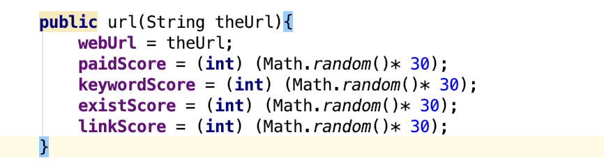

* Manipulate method && Asscess Method

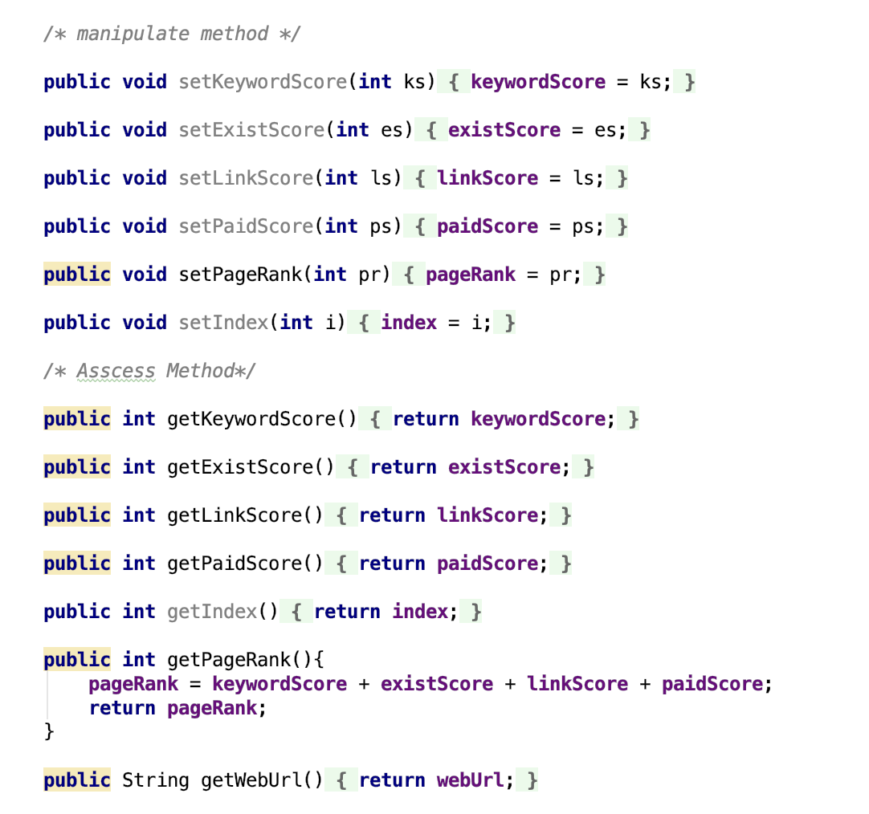

5. Self-tesing screen shots

* BuildMaxHeap(A) $→$ A array with decending order

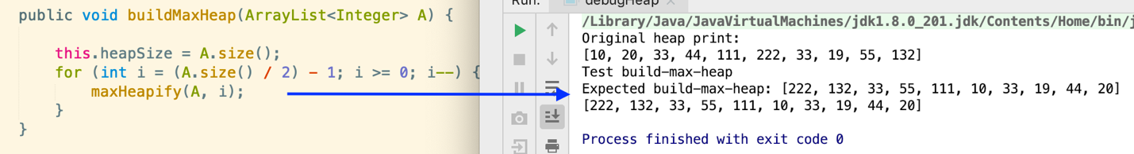

* HeapSort(A) $→$ An array sorts with acending order

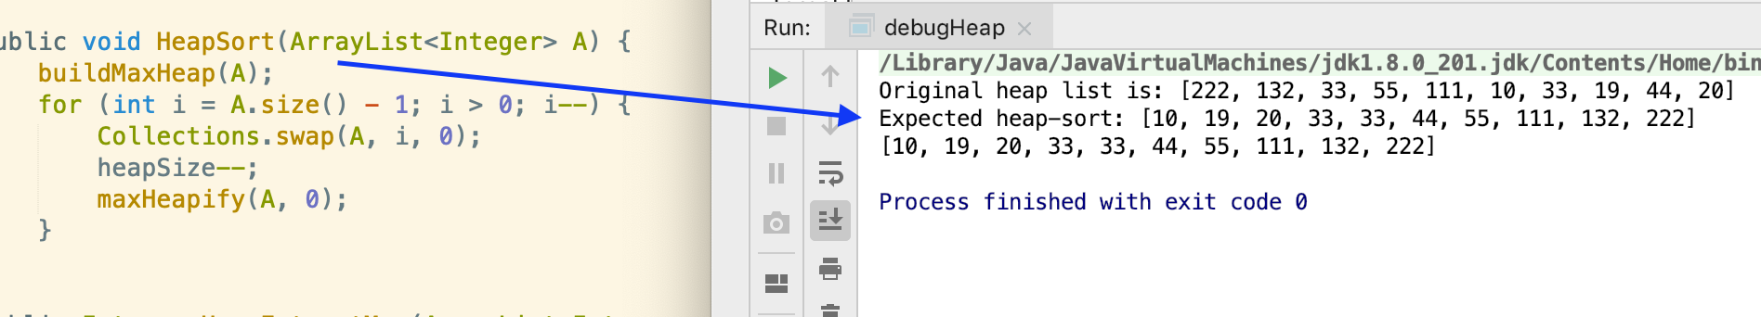

* heapMaximum(A) $→$ get the maximum

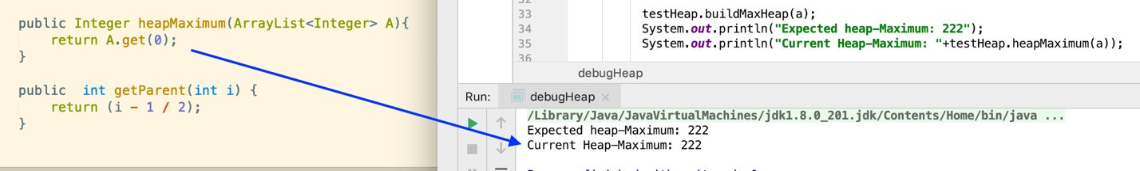

* tesing heapIncresekey() && MaxHeapInsert()

$→$ adding a element

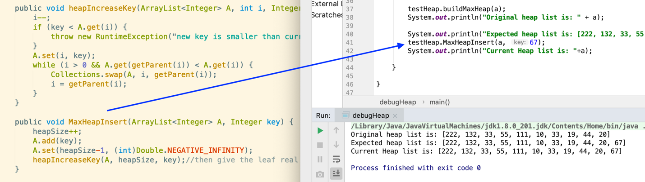

* Testing HeapExtractMax(A)

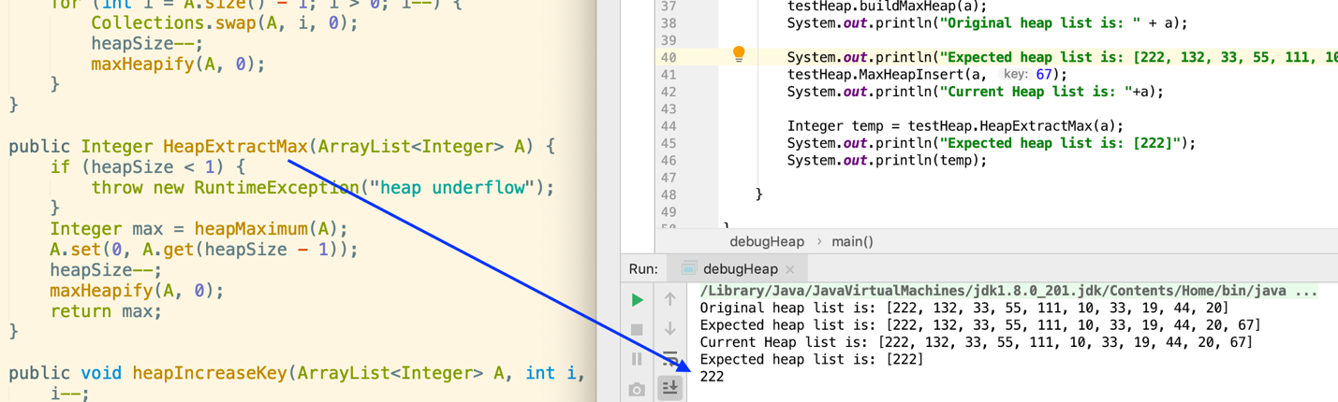

* Testing WebCrawler

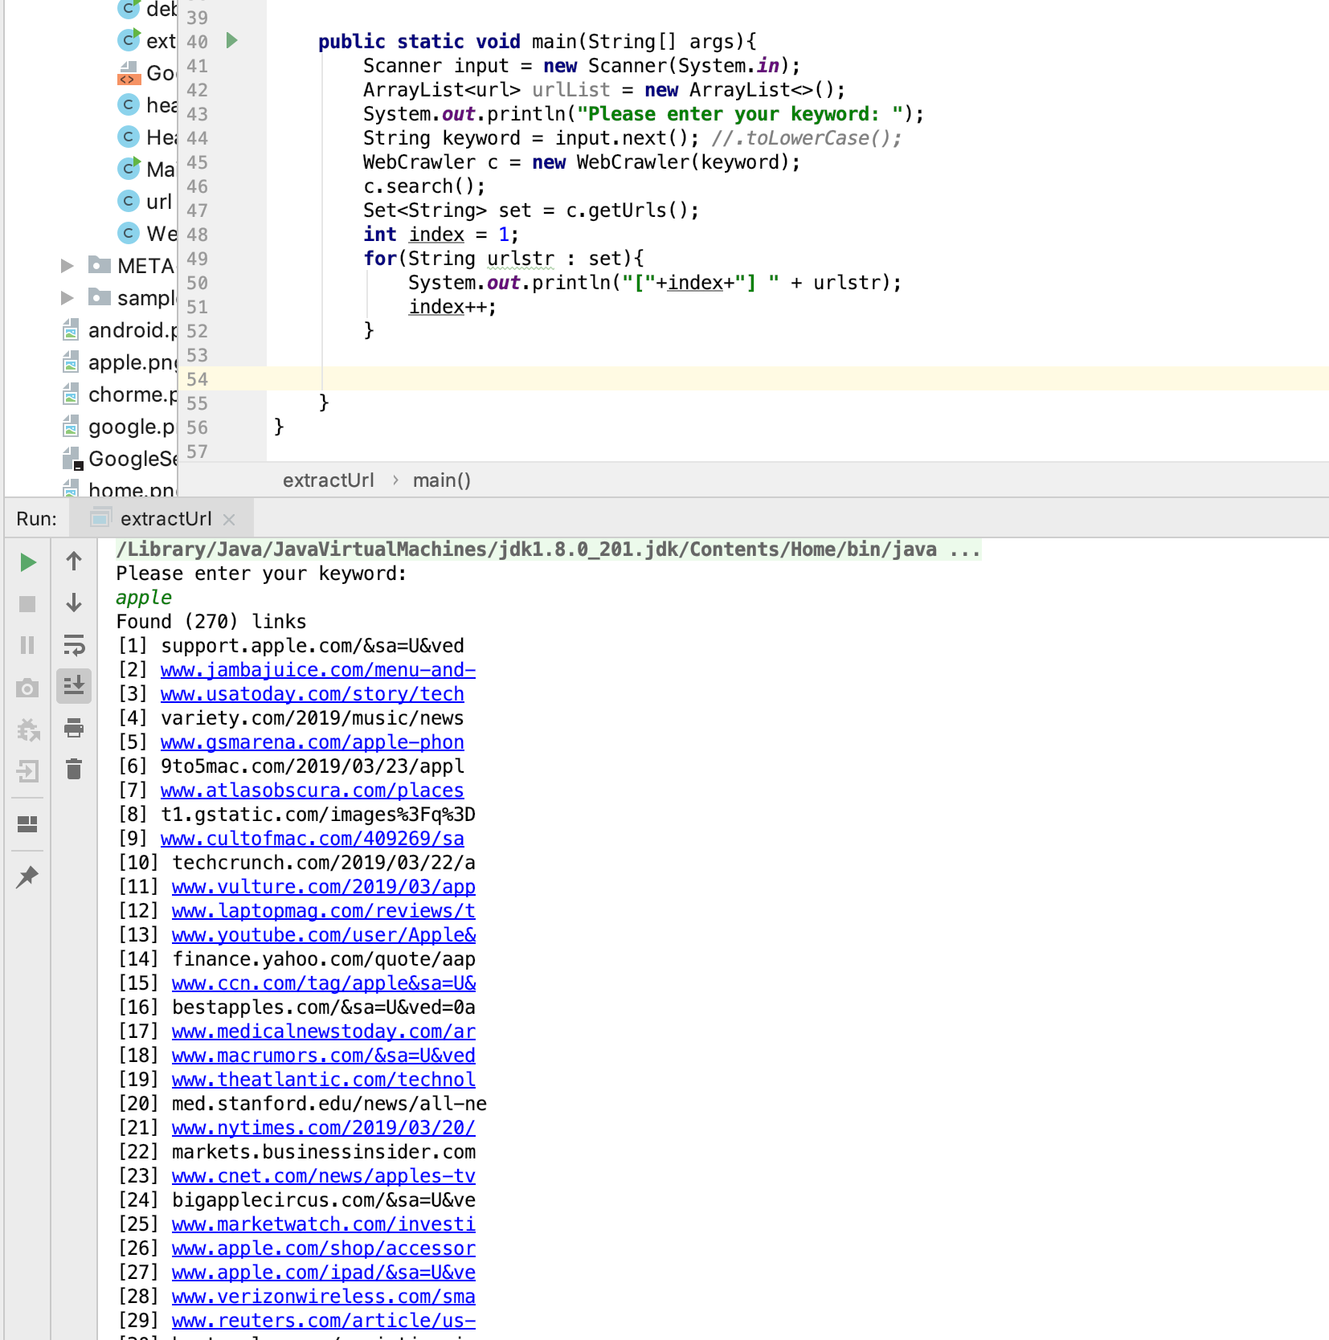

* Testing searchBtn $→$ input “windows” out 30 url

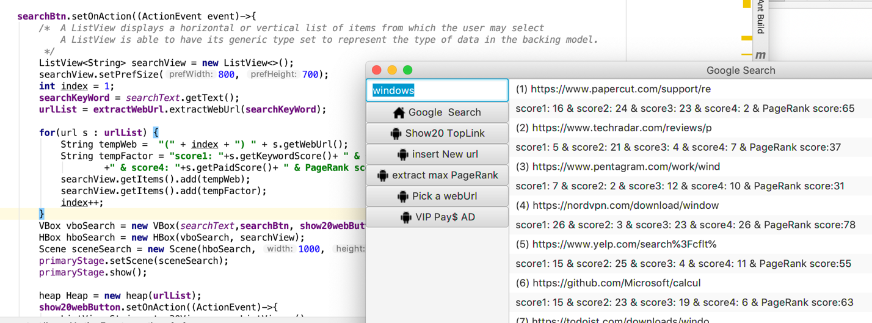

* Testing show20webButton

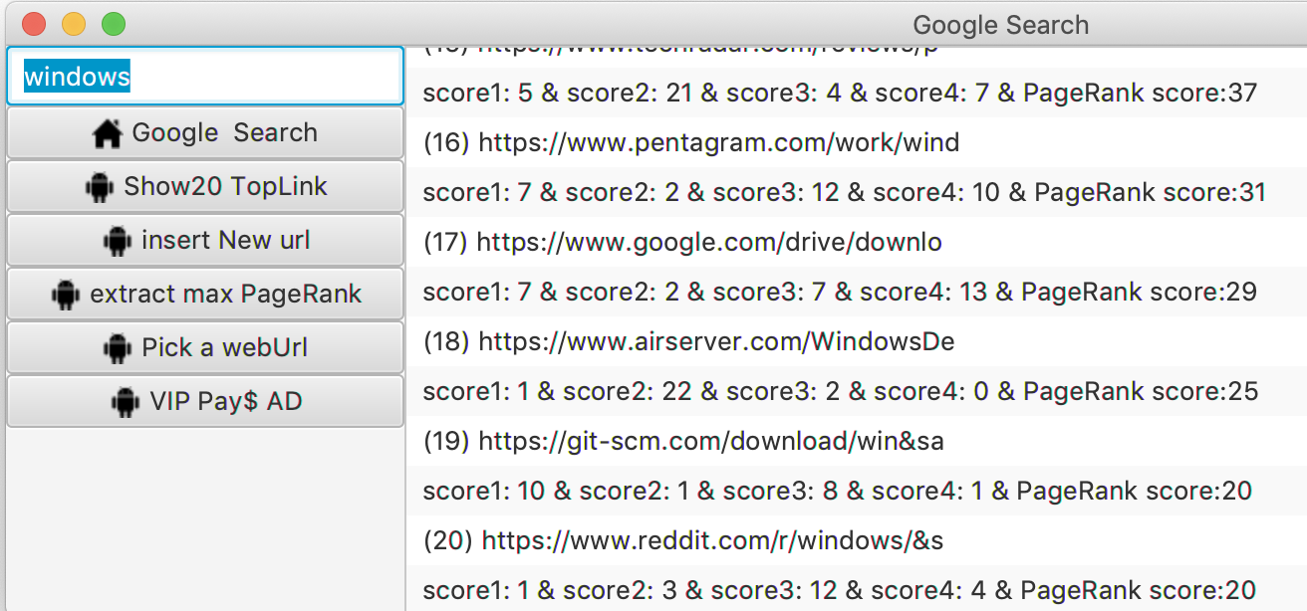

* Testing insertNewButton

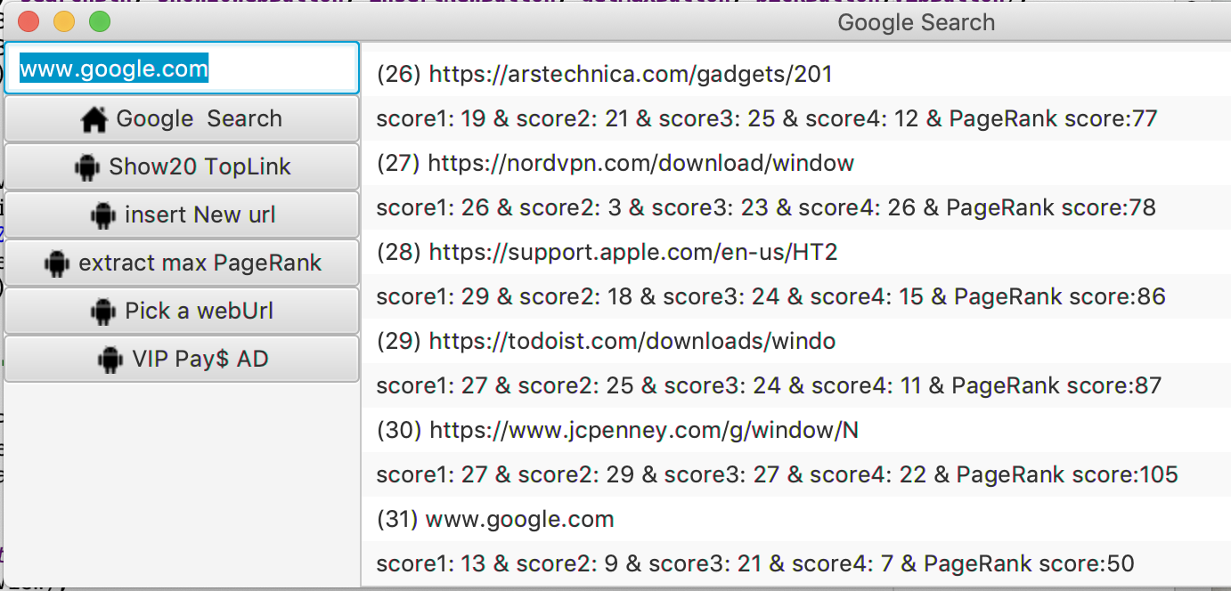

* Testing getMaxButton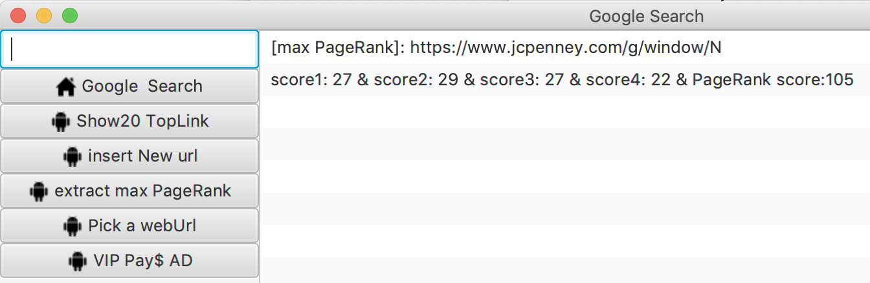
* Testing pickButton

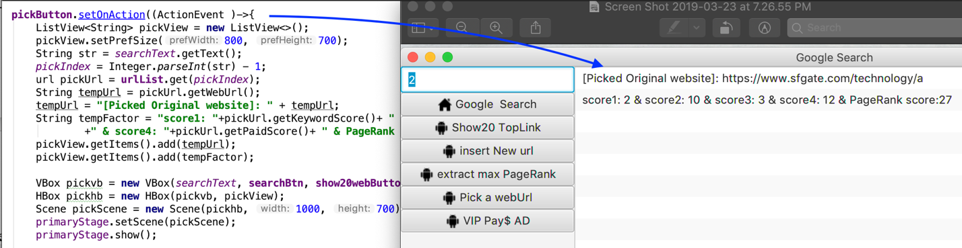

* Testing vipButton



6. Problems encountered during implementation

* Originally, I wrote all event method in Main class step by step
* $→$ Firstly, I didn’t know if the scope of searchButton will affect the following button events.
* $→$ After struggling for more than 5 hours, I relized my mistake that the orther buttons Events must inside the searchButton’s scope:

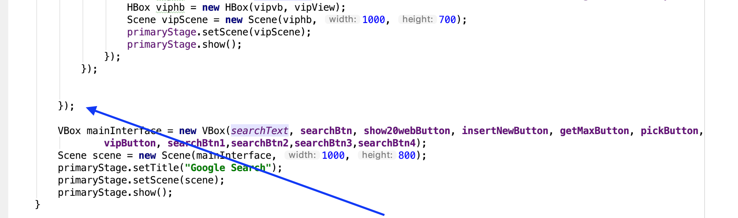

* vipButton must be inside the pickButton’s scope, otherwise, vipButton cannot know which index that is user picked and required.

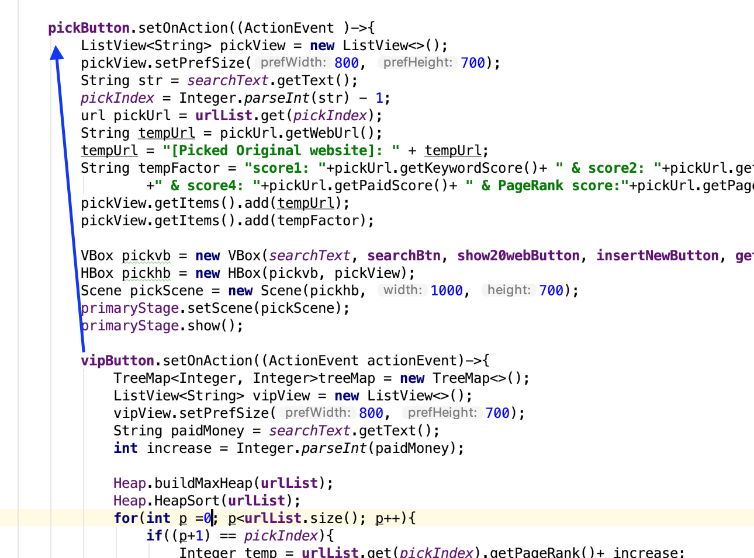

* All buttons must be on Vbox, then the UI interface will show all buttons vertically.



7. Leasson Learned

* While I encountered problems during the implementation, I learned to debug and create tested class for debugging:

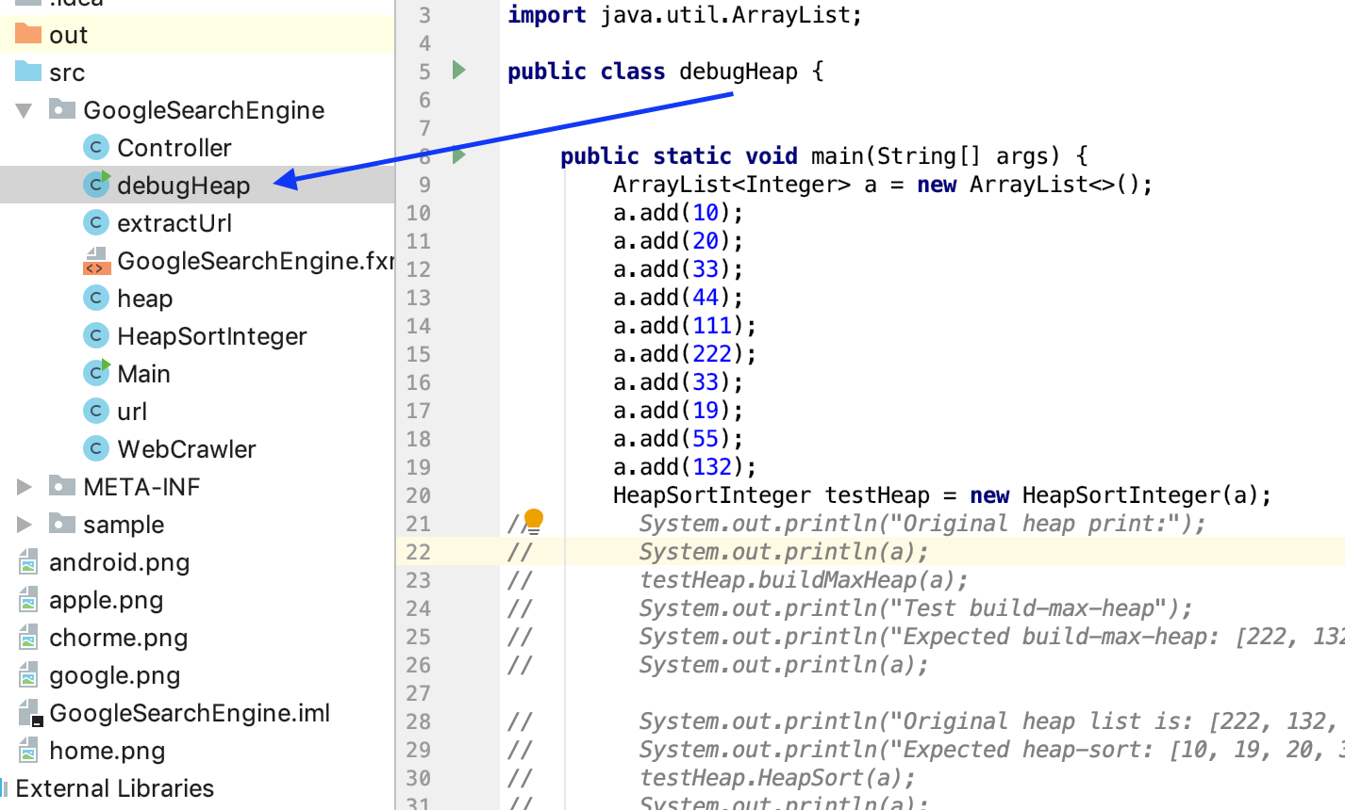

* Then I find out the mistake: the arrayList must add a new key, then it will automatically

Increasing it’s size.

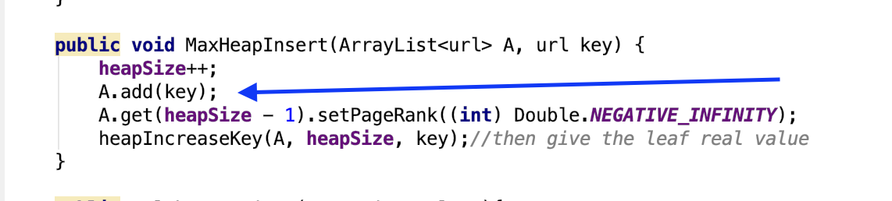

* Sometimes, professor Wu will help me to solve the problem that I have no idea:

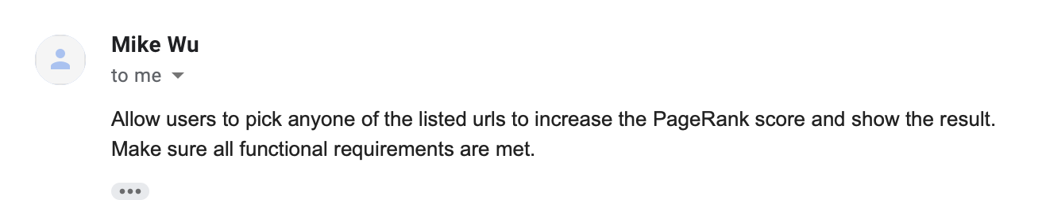

* I learn to write a professional report in MS word fromat.
* Learning to test .jar file.

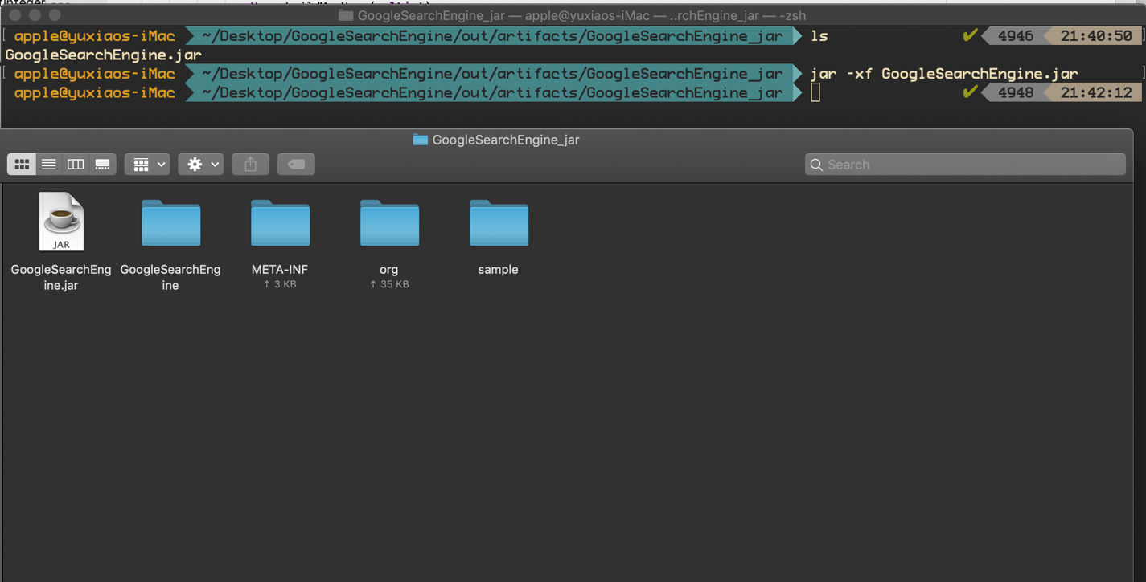

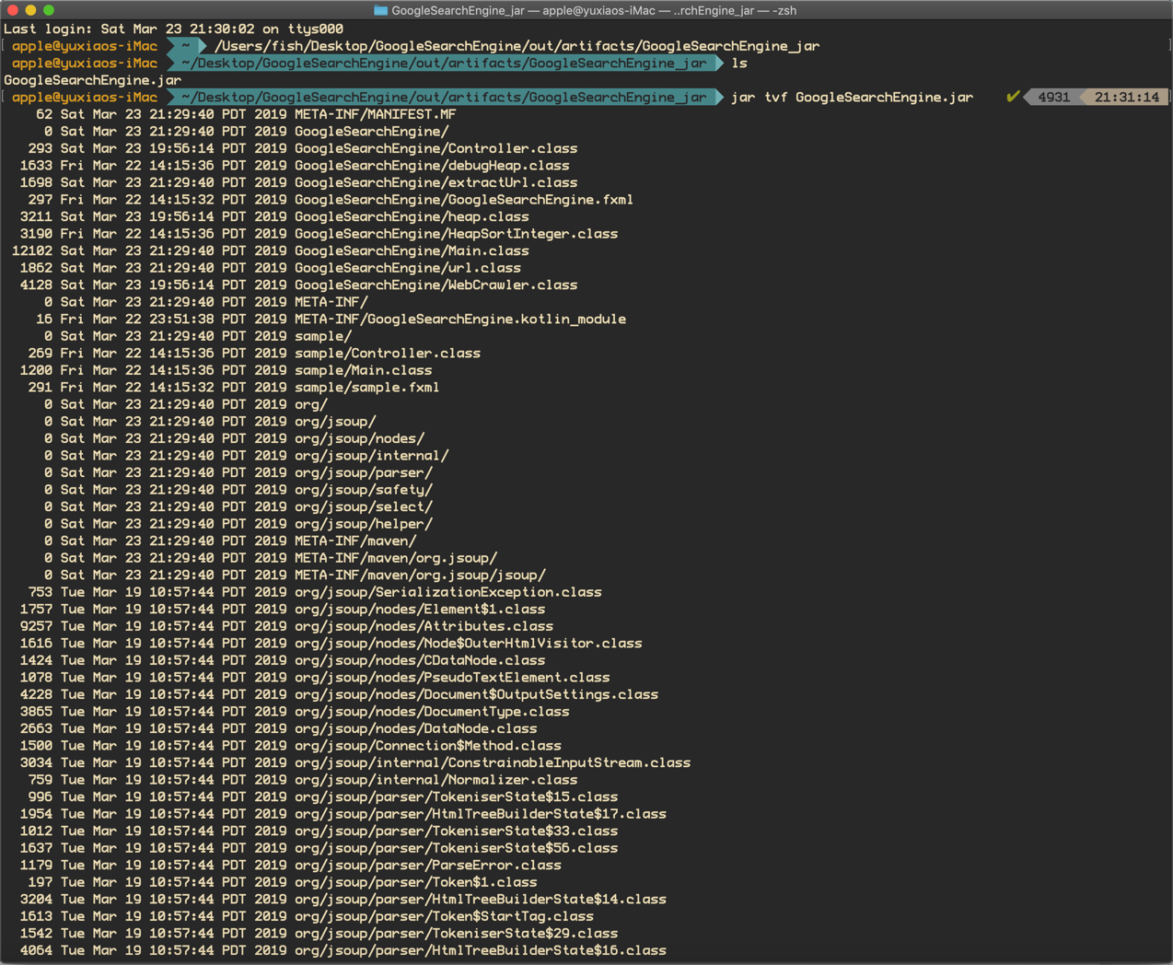

8. Updating (Debugging Report)

During last version, after increasing the score that the user picked, I forgot to resort the web url.

This time I updating this new edition:

* Input the keyword: java coding

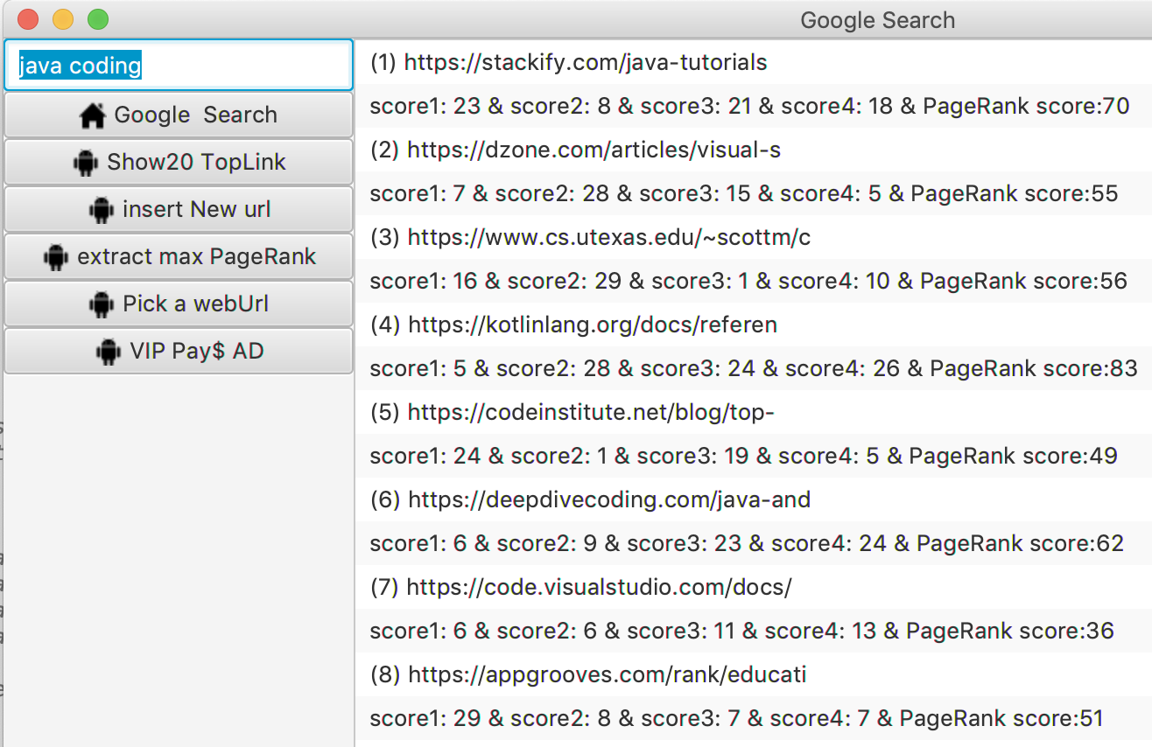

* Picking the 7th index

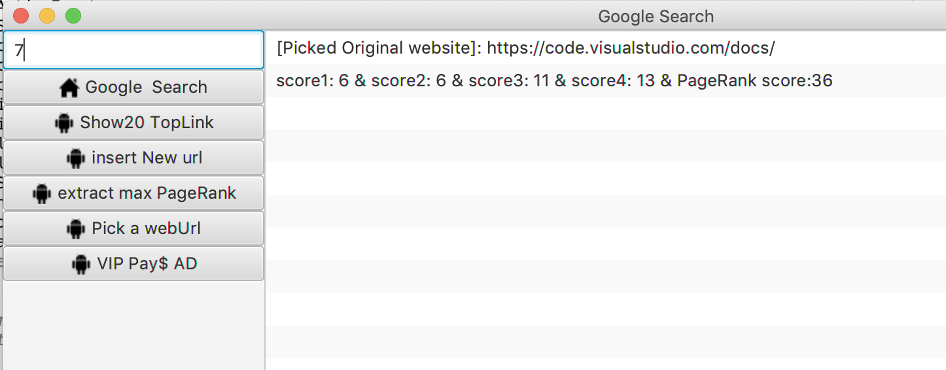

* Increasing the score that the user required.

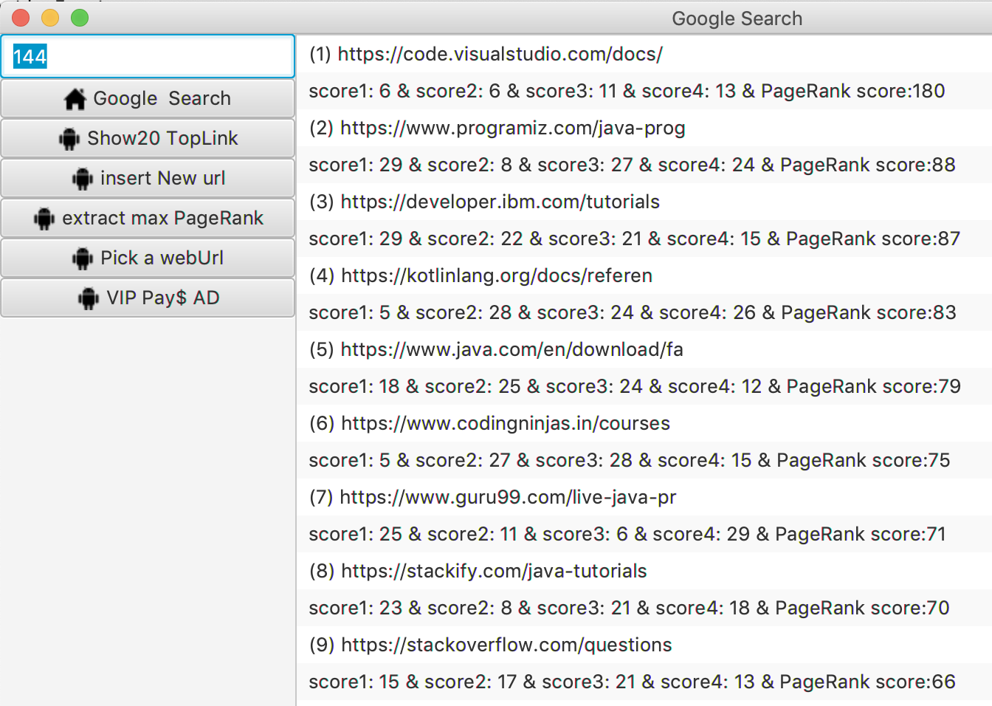

* The below pictures are how to implement the requirement:

